بسم الله الرحمن الرحيم



Education Spending and Economic Growth Analysis

Selected Programming Language
Supervised By: Prof. Eslam Al-Hersh

Team Member | ID
Faisal Jaber Naem | 221983
Taha Mahmoud Abo Al-Hija | 231643

Department: Computer Science
Faculty: Faculty of Information Technology
University: University of Jerash
Semester: First Semester 2025/2026
Submission Date: 5th of January 2026

Abstract

This project analyzes the relationship between education spending and economic growth using a global, country-level dataset derived from World Bank indicators. Education expenditure, measured as a percentage of gross domestic product (GDP), is examined in relation to annual GDP growth rates, alongside additional macroeconomic variables including unemployment, inflation, and population growth. The study follows a structured data science workflow implemented in the R programming language, encompassing data import, cleaning, exploratory data analysis (EDA), modeling, and evaluation.
After transforming the raw data into a tidy and analysis-ready format, exploratory visualizations are used to examine global patterns, temporal trends, and potential outliers in the data. Both statistical and machine learning approaches are applied to model economic growth outcomes. Linear regression models are used to establish baseline relationships between education spending and GDP growth, with and without additional control variables. A random forest regression model is subsequently implemented to capture potential non-linear relationships and improve predictive performance. Model evaluation is conducted using standard metrics, including Root Mean Squared Error (RMSE) and the coefficient of determination (R²), based on a train–test split of the data.
The results provide descriptive and predictive insights into the association between education spending and economic growth at the global level. The findings are interpreted cautiously, emphasizing that the analysis is observational in nature and does not establish causal relationships. Overall, the project demonstrates the application of a complete data science and machine learning pipeline in R within the context of an applied economic analysis.

Table of Contents
1. Introduction 5
2. Data Overview 6
2.1 Data Source 6
2.2 Variables and Indicators 6
2.3 Unit of Analysis and Time Structure 7
2.4 Data Organization and Reproducibility 7
3. Data Cleaning and Preparation 8
3.1 Initial Import and Variable Selection 8
3.2 Data Reshaping and Transformation 8
3.3 Data Type Conversion 8
3.4 Handling of Missing Values 9
3.5 Final Dataset Output 9
4. Exploratory Data Analysis 10
4.1 Global Relationship Between Education Spending and Economic Growth 10
4.2 Distribution of Key Economic Variables 11
4.3 Education Spending Over Time: Jordan and Global Context 12
4.4 Summary of EDA Findings 13
5. Machine Learning Model 14
5.1 Baseline Linear Regression Models 14
5.2 Random Forest Regression Models 14
5.3 Model Output and Reproducibility 15
6. Model Evaluation 16
6.1 Evaluation Metrics 16
6.2 Predicted vs Actual GDP Growth 16
6.3 Reproducibility Outputs 18
7. Results and Discussion 19
8. Conclusion 20
9. References 21

Introduction

Education spending is widely regarded as an important component of long-term economic development, as it contributes to human capital formation, labor productivity, and innovation. Governments allocate varying proportions of their national income to education, raising important questions about how such investments are associated with economic performance at the macroeconomic level. Understanding this relationship is particularly relevant in a global context, where countries differ substantially in their economic structures, demographic trends, and policy priorities.
This project examines the relationship between education spending and economic growth using a global, country-level dataset. Education expenditure is measured as a percentage of gross domestic product (GDP), while economic growth is represented by annual GDP growth rates. To provide additional context and account for broader macroeconomic conditions, the analysis also considers several control variables, including unemployment rates, inflation, and population growth. The unit of analysis is the country-year, allowing the study to capture both cross-country variation and changes over time.
The analysis follows a structured data science and machine learning workflow implemented in the R programming language. The project begins with data import and cleaning, where raw World Bank indicators are transformed into a tidy and analysis-ready dataset. This is followed by exploratory data analysis (EDA), which is used to visualize global patterns, examine trends over time, and identify potential outliers in the data. Based on these insights, both statistical and machine learning models are applied. Linear regression models are used to establish baseline relationships between education spending and economic growth, while a random forest regression model is employed to capture potential non-linear patterns and improve predictive performance.
Model performance is evaluated using standard predictive metrics, including Root Mean Squared Error (RMSE) and the coefficient of determination (R²), based on a train–test split of the data. It is important to emphasize that this study focuses on associative and predictive relationships rather than causal inference. The findings should therefore be interpreted as descriptive insights derived from observed data. Overall, the project aims to demonstrate the application of a complete data science and machine learning pipeline in R within the context of an applied global economic analysis.

Data Overview

2.1 Data Source
The data used in this project were obtained from the World Bank World Development Indicators (WDI) database. The WDI is a publicly available and widely used data source that provides standardized economic, social, and demographic indicators for countries worldwide. Data were collected for multiple countries over several years, resulting in a global, country-level panel dataset.
The dataset was constructed by selecting a set of relevant indicators from the World Bank database and exporting them as a comma-separated values (CSV) file. These indicators were chosen to represent education investment, economic growth, and key macroeconomic conditions. The exported file was then stored locally and used as the raw input for the analysis pipeline.

2.2 Variables and Indicators
The raw dataset contains country identifiers, indicator codes, and annual observations by year. From this dataset, the following variables were selected for analysis:
- Education Spending (% of GDP): Government expenditure on education expressed as a percentage of gross domestic product.
- GDP Growth (%): Annual percentage growth rate of GDP at market prices.
- Unemployment Rate (%): Share of the labor force that is unemployed.
- Inflation (%): Annual percentage change in consumer prices.
- Population Growth (%): Annual population growth rate.
These variables were selected to allow the analysis of education spending in relation to economic growth while accounting for broader macroeconomic conditions.

Table 1. Variables and Corresponding World Bank Indicator Codes
 | Description | World Bank Indicator Code
  Variable Name
  Education Spending (% of GDP)
  Government expenditure on education as a share of GDP
  SE.XPD.TOTL.GD.ZS
 | Annual percentage growth rate of GDP
  GDP Growth (%)
  NY.GDP.MKTP.KD.ZG
Unemployment Rate (%) | Share of the labor force that is unemployed
  SL.UEM.TOTL.ZS
Inflation (%) |  | FP.CPI.TOTL.ZG
  Annual percentage change in consumer prices
 |  | SP.POP.GROW
  Population Growth (%)
  Annual population growth rate

The official World Bank indicator codes corresponding to each variable are provided in Table 1.

2.3 Unit of Analysis and Time Structure
The unit of analysis in this study is the country-year. Each observation represents a single country in a specific year, allowing the dataset to capture both cross-country differences and temporal variation over time. This structure supports exploratory analysis, regression modeling, and machine learning approaches applied later in the project.

2.4 Data Organization and Reproducibility
The raw data file was stored in a structured project directory and accessed using relative file paths within the R scripts. This organization ensures that the analysis is reproducible and portable across different systems. All subsequent data cleaning, transformation, visualization, modeling, and evaluation steps are based on this initial raw dataset.

Data Cleaning and Preparation

This section describes the steps used to transform the raw dataset into a clean, structured format suitable for exploratory analysis and modeling. All data cleaning and preparation procedures were implemented in R using a reproducible script, ensuring consistency and transparency throughout the workflow.

3.1 Initial Import and Variable Selection

The raw dataset was imported from a CSV file containing World Bank indicators for multiple countries and years. Upon import, column names were standardized to a consistent and readable format to improve clarity and prevent downstream errors. From the full set of available indicators, only those relevant to the research objective were retained. These included education spending, GDP growth, unemployment, inflation, and population growth.
This initial filtering step reduced the dimensionality of the dataset and ensured that subsequent analyses focused exclusively on variables of interest.

3.2 Data Reshaping and Transformation

The raw data were originally structured in a wide format, with annual observations stored across multiple columns. To facilitate analysis, the data were first reshaped into a long format, allowing year values to be treated explicitly as a variable. The year column was then converted from character format to a numeric representation.
Following this transformation, the dataset was reshaped back into a wide format, with each selected indicator represented as its own column. This structure resulted in one row per country-year observation, aligning the data with the intended unit of analysis and enabling straightforward application of regression and machine learning methods.

3.3 Data Type Conversion
After reshaping, all indicator variables were explicitly converted to numeric data types. This step was necessary to ensure compatibility with statistical modeling and machine learning algorithms, which require numeric inputs. Performing these conversions early in the pipeline also helped identify and prevent potential data type inconsistencies.

3.4 Handling of Missing Values

Observations with missing values in key variables were removed from the dataset. In particular, rows lacking information on education spending or GDP growth were excluded, as these variables are central to the analysis. This approach ensured that all retained observations contained complete information required for exploratory analysis and model training.
No imputation methods were applied, as the goal was to maintain transparency and avoid introducing additional assumptions into the dataset.

3.5 Final Dataset Output

After cleaning and preparation, the final dataset was saved as a new CSV file in a designated output directory. This cleaned dataset served as the sole input for all subsequent exploratory data analysis, modeling, and evaluation steps. Separating the cleaned data from the raw input file supports reproducibility and allows the entire analysis pipeline to be rerun from the original source data if needed.

Exploratory Data Analysis

Exploratory Data Analysis (EDA) was conducted to examine the structure, distribution, and basic relationships within the cleaned dataset prior to modeling. The goal of this stage is to gain descriptive insights, identify patterns and variability, and inform subsequent modeling choices, without making causal claims.

4.1 Global Relationship Between Education Spending and Economic Growth
Figure 1: Global Relationship Between Education Spending and Economic Growth
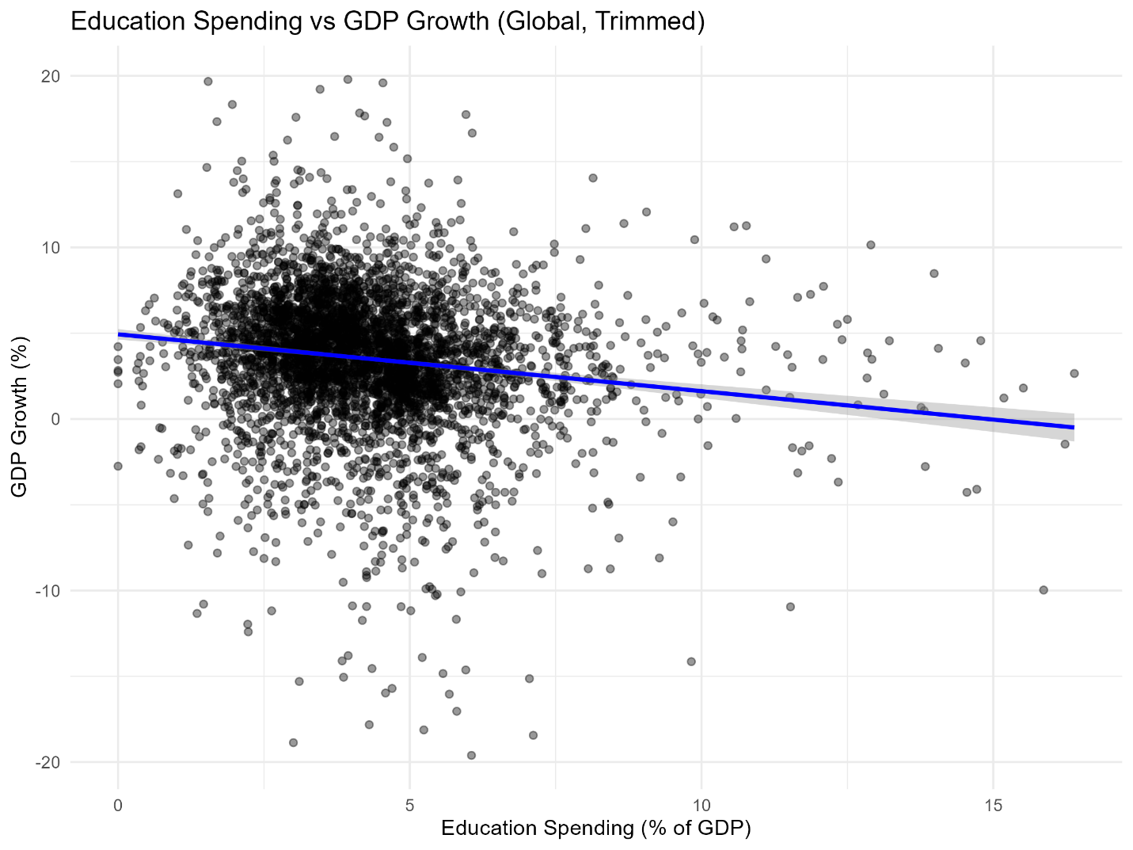

Figure 1 presents the relationship between education spending (as a percentage of GDP) and GDP growth at the global level. Each point represents a country-year observation. To improve visual clarity and reduce the influence of extreme observations, GDP growth values were trimmed to a reasonable range for visualization purposes only.
The scatter plot shows substantial dispersion in GDP growth rates across different levels of education spending, indicating a weak and noisy relationship. The fitted trend line suggests a slight negative association; however, the wide spread of observations highlights considerable heterogeneity across countries and time periods. This visual evidence suggests that education spending alone is insufficient to explain variations in economic growth and motivates the inclusion of additional explanatory variables and more flexible modeling approaches.

4.2 Distribution of Key Economic Variables
Figure 2: Distribution of Key Economic Variables
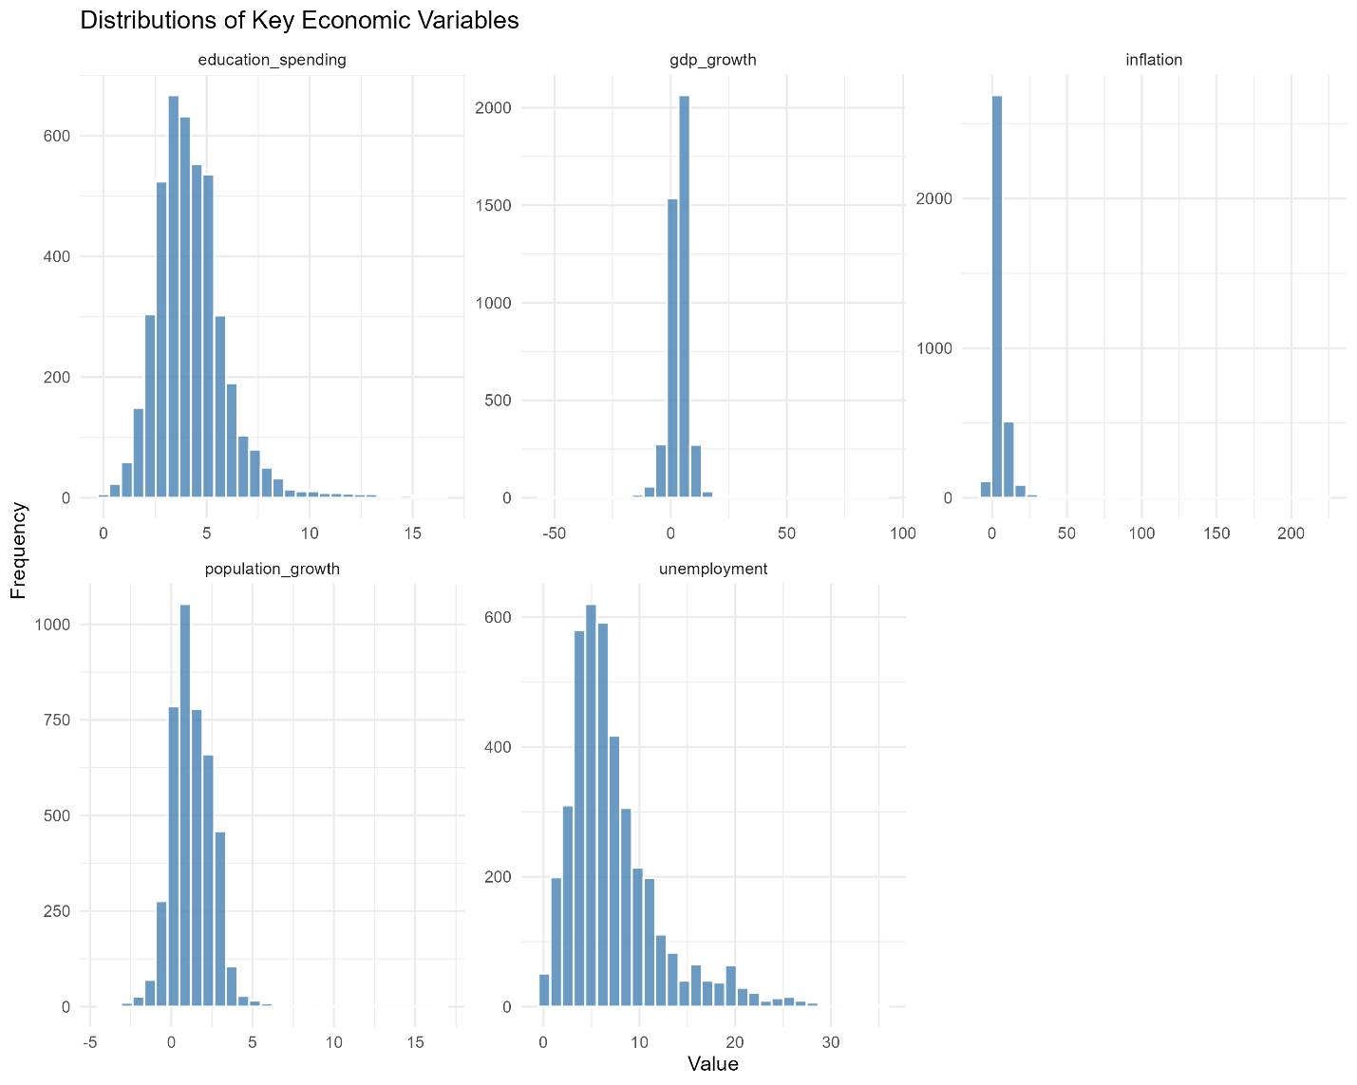

Figure 2 displays the distributions of the main variables used in the analysis, including education spending, GDP growth, inflation, population growth, and unemployment. All histograms are presented together in a single figure to provide a compact overview of variable behavior.
Several variables exhibit skewness and the presence of outliers, particularly GDP growth and inflation. Education spending appears more concentrated within a narrower range, while unemployment shows a right-skewed distribution. These distributional characteristics indicate that strict normality assumptions may not hold, supporting the later use of machine learning methods that are less sensitive to distributional form.

4.3 Education Spending Over Time: Jordan and Global Context

Figure 3: Education Spending Over Time: Jordan and Global Context
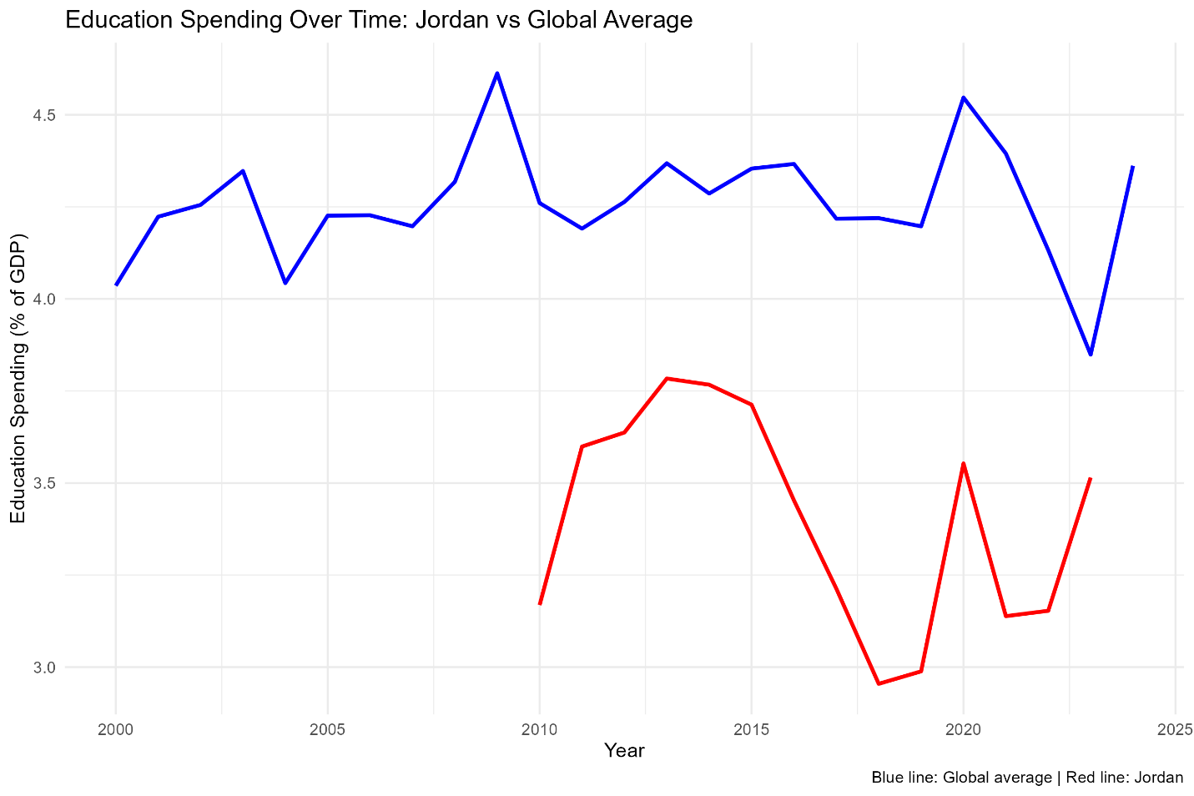

Figure 3 illustrates trends in education spending over time, comparing Jordan with the global average. This figure is included for contextual and illustrative purposes only and does not imply a country-specific modeling focus.
The global average education spending remains relatively stable over time, with moderate fluctuations. In contrast, Jordan exhibits greater year-to-year variability and generally lower spending levels relative to the global average. This comparison highlights cross-country differences in education investment patterns and provides temporal context for the broader global analysis.

4.4 Summary of EDA Findings

Overall, the exploratory analysis reveals substantial variability in economic growth outcomes across countries and time, as well as non-uniform distributions in key variables. The observed patterns suggest that the relationship between education spending and economic growth is complex and influenced by multiple factors. These findings motivate the use of both regression-based and machine learning models in the subsequent analysis to better capture underlying relationships.

Machine Learning Model

This section describes the modeling approaches used to analyze and predict economic growth based on education spending and selected macroeconomic variables. Both statistical and machine learning models were applied to capture different types of relationships present in the data.

Baseline Linear Regression Models
As an initial modeling step, linear regression models were used to establish baseline relationships between education spending and economic growth. Linear regression provides a simple and interpretable framework for assessing average associations between variables.
The first model includes education spending as the sole explanatory variable, allowing for a direct examination of its relationship with GDP growth. A second extended model incorporates additional macroeconomic control variables—unemployment, inflation, and population growth—to account for broader economic conditions that may influence growth outcomes. These models serve as reference points against which more flexible machine learning methods can be compared.
Regression results were summarized in tabular form and exported for reporting purposes. The linear models are not intended to provide causal estimates, but rather to offer a transparent baseline for understanding general trends in the data.

Random Forest Regression Models

To capture potential non-linear relationships and complex interactions among variables, a random forest regression model was implemented. Random forests are ensemble-based machine learning methods that combine multiple decision trees to improve predictive accuracy and reduce overfitting.
The random forest model was trained using education spending, unemployment, inflation, and population growth as input features, with GDP growth as the target variable. Prior to training, the dataset was split into training and testing subsets using a 70/30 split to allow for out-of-sample evaluation. Cross-validation was applied during model training to improve robustness and reduce sensitivity to random sampling variation.
This machine learning approach complements the linear regression models by allowing for greater flexibility in capturing patterns that may not be well represented by linear assumptions.

5.3 Model Output and Reproducibility

The trained random forest model was saved as a serialized object to enable reproducibility and reuse without retraining. All modeling steps were executed using fixed random seeds to ensure consistent results across runs. This structured approach supports transparent comparison between modeling techniques and ensures that results can be replicated using the provided scripts.

Model Evaluation

This section evaluates the predictive performance of the machine learning model using out-of-sample data. Model assessment was conducted on a held-out test set to provide an unbiased measure of performance. Both quantitative metrics and visual diagnostics are used to assess how well the model predicts GDP growth.

Evaluation Metrics

Model performance was evaluated on the test set using Root Mean Squared Error (RMSE) and the coefficient of determination (R²). These metrics were selected to assess both prediction accuracy and the proportion of variance in GDP growth explained by the model.

The random forest model achieved an RMSE of [RMSE value] and an R² of [R² value], as reported in Table 2. The RMSE reflects the average magnitude of prediction errors in percentage points of GDP growth, while the R² value indicates that a limited but non-zero share of the variability in economic growth is captured by the model.

These results suggest that while the model is able to identify general patterns in the data, a substantial portion of variation in GDP growth remains unexplained. This outcome is consistent with the complex and multifactorial nature of macroeconomic growth processes.

Table 2. Random Forest Model Evaluation Metrics (Test Set)
Metric | Value
RMSE | 3.540759
$$R^{2}$$ | 0.1708

Predicted vs Actual GDP Growth
Figure 4: Predicted vs Actual GDP Growth
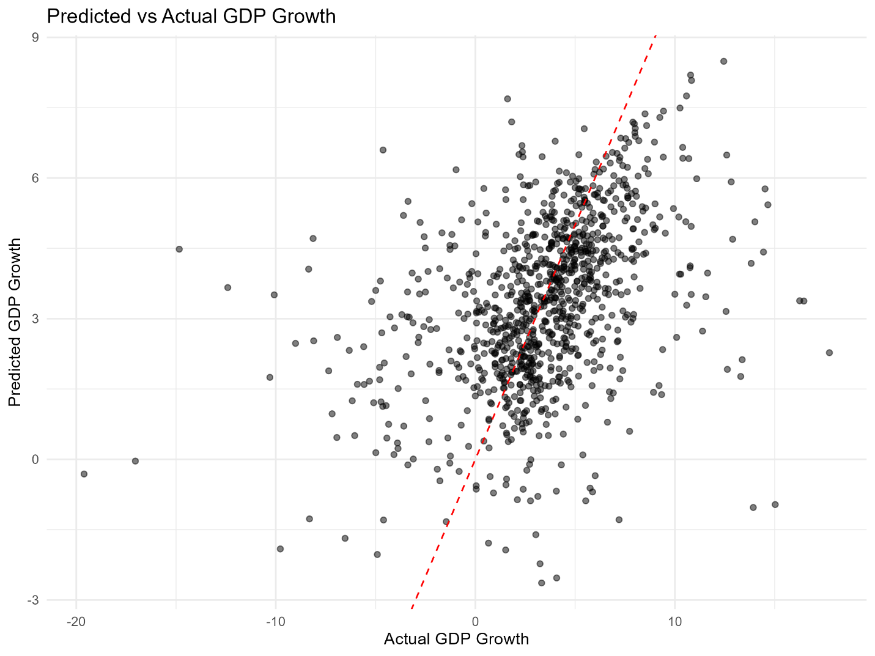

Figure 4 compares the predicted GDP growth values produced by the random forest model with the actual observed values in the test dataset. Each point represents a country-year observation, while the dashed 45-degree reference line indicates perfect prediction.
The concentration of points around the reference line suggests that the model captures general trends in GDP growth reasonably well. However, noticeable dispersion remains, particularly for extreme growth values, indicating that prediction errors increase in periods of unusually high or low economic growth. This pattern is consistent with the inherent volatility of macroeconomic outcomes and highlights the difficulty of predicting growth using a limited set of explanatory variables.
Overall, the plot complements the reported evaluation metrics by providing a visual assessment of model performance and illustrating the balance between predictive signal and unexplained variation.

Reproducibility Outputs

To support reproducibility and transparency, additional evaluation outputs were saved during the analysis process. Model predictions for the test set were exported to a CSV file, enabling further inspection or reuse without rerunning the evaluation pipeline. In addition, the trained random forest model was saved as a serialized R object, allowing the model to be reloaded and applied to new data without retraining.

Results and Discussion

This section synthesizes the findings from the exploratory data analysis, regression models, and machine learning evaluation to provide a coherent interpretation of the results. The discussion focuses on observed patterns and predictive performance rather than causal inference.
The exploratory analysis revealed substantial heterogeneity in GDP growth across countries and over time. Visualizations showed a weak and noisy relationship between education spending and economic growth at the global level, with considerable dispersion even after trimming extreme values for visualization purposes. Distributional plots further indicated skewness and the presence of outliers in several variables, highlighting the complexity of macroeconomic data and the limitations of relying on single explanatory factors.
Results from the baseline linear regression models were consistent with the EDA findings. Education spending alone did not strongly explain variation in GDP growth, and the inclusion of additional macroeconomic control variables modestly improved model specification without fully accounting for observed variability. These results suggest that while education spending is an important structural component of economic systems, its short-term association with annual growth rates is limited when considered in isolation.
The random forest model demonstrated moderate predictive performance on the test dataset, as reflected in the reported RMSE and R² values. The predicted versus actual GDP growth plot showed that the model was able to capture general trends in economic growth, but also exhibited noticeable prediction errors, particularly during periods of extreme growth or contraction. This outcome underscores the inherent difficulty of predicting macroeconomic growth using a limited set of aggregate indicators.
Overall, the findings indicate that education spending is associated with economic growth in a complex and indirect manner. A substantial portion of variation in GDP growth remains unexplained by the variables included in this study, likely reflecting the influence of institutional, political, technological, and external factors not captured in the dataset. These results reinforce the importance of cautious interpretation and confirm that the analysis should be viewed as descriptive and predictive rather than causal.

Conclusion

This project examined the relationship between education spending and economic growth using a global, country-level dataset derived from World Bank indicators. Following a structured data science and machine learning pipeline in R, the analysis progressed from data acquisition and cleaning to exploratory visualization, modeling, and evaluation. Both statistical and machine learning approaches were applied to provide complementary perspectives on the data.
Exploratory data analysis revealed substantial heterogeneity in economic growth outcomes across countries and time periods, as well as weak and noisy associations between education spending and annual GDP growth rates. Baseline linear regression models supported these observations, showing that education spending alone explains only a limited portion of variation in economic growth, even when additional macroeconomic control variables are included. The random forest model provided moderate predictive performance, capturing general trends while leaving a significant share of growth variability unexplained.
These findings highlight the complexity of macroeconomic growth processes and suggest that education spending, while structurally important for long-term development, is not sufficient on its own to explain short-term fluctuations in GDP growth at the global level. The analysis emphasizes association and prediction rather than causation, and the results should be interpreted accordingly.
Several limitations should be noted. The study relies on aggregate country-level indicators, which may mask important within-country dynamics and institutional factors. In addition, the set of explanatory variables is necessarily limited and does not capture political, technological, or external economic shocks that can strongly influence growth outcomes. Future work could incorporate a broader range of variables, longer time horizons, or alternative modeling approaches to further explore these relationships. Overall, the project demonstrates the practical application of a complete data science and machine learning workflow in R within an applied economic context.

References

World Bank. World Development Indicators.
https://databank.worldbank.org/source/world-development-indicators
R Core Team. R: A Language and Environment for Statistical Computing. R Foundation for Statistical Computing, Vienna, Austria.
Wickham, H., et al. Welcome to the tidyverse. Journal of Open Source Software, 2019.
Wickham, H. ggplot2: Elegant Graphics for Data Analysis. Springer, 2016.
Kuhn, M. caret: Classification and Regression Training. R package documentation.

